**UPCOMING EVENTS IN THE COMMUNITY**

* 2nd Wednesday- February 12th at 6pm Chili Cookoff at Salem Methodist. All are welcome!
* February 14th High School Districts will be played at Drummond! See the school website for times.
* February 17th Town Offices will be closed for Presidents Day.
* NO SCHOOL February 21st
* Kingdom Quest every Wednesday 3:30- 5:00 pm for grades K through 5th Questions call Brenda Vasquez at 580-542-2531

**MUSEUM NEWS**

The Drummond Museum opened a photo exhibit by Simone Mattea on January 22nd with a presentation on January 25th and 26th. We had 21 attendees on Saturday and 16 on Sunday. Thanks to everyone that came out to support the exhibit. We would also like to thank Robin Holmes who brought her sophomore art class to the exhibit on Tuesday, January 28th. There were 14 students who attended the exhibit. The photo exhibit will run through March 2nd. Please come by and view photos of Drummond as captured by a local photographer.

**SMARTIES!!**

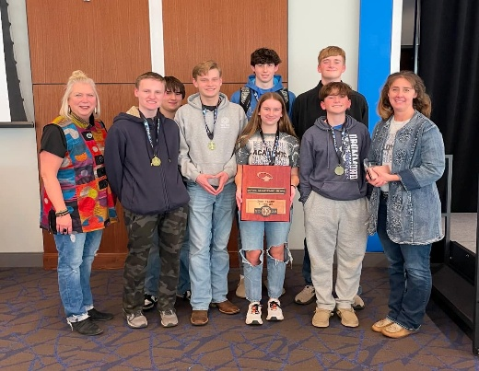Drummond High School Academics team took 3rd place.

7/8 Grade Quiz Bowl competed in Area Tournament and placed 2nd

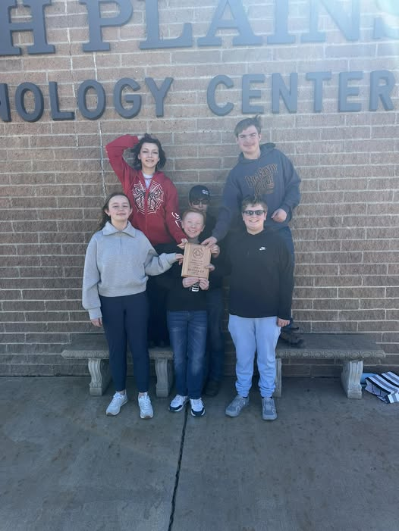

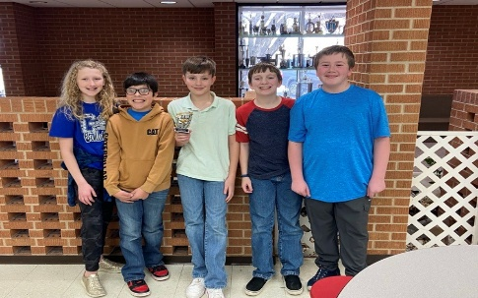5/6 Grade Quiz Bowl competed in the OJABA regional and placed 1st and 2nd both qualified for state!

Congratulations to all these wonderful kids! You make Drummond proud!

**SHOP 40% ALL MONTH AT SEI BELLA**

Valentine’s Day is

Feb 14th! Shop Sei Bella on Main for 40% off!